Report PL2.

The second part in MS Project.

1. Setting up the project.

First, the data from the given table is introduced into the program and completed its columns with the values from the problem. The beginning and ending dates are created based on the day of creation of the project.

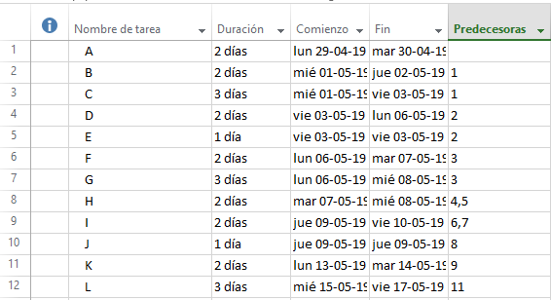

1. Network diagram.

To create the network diagram, the “diagrama de red” is selected from the options.

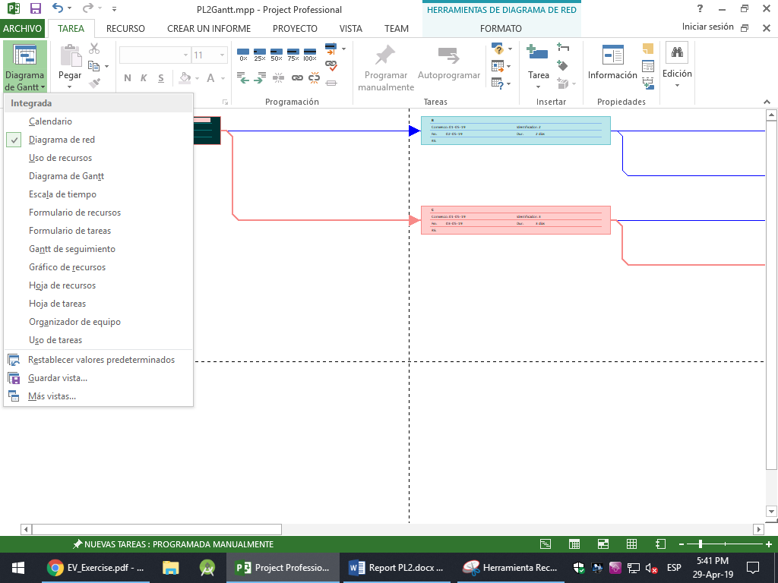

Then, based on the data previously introduced, a full column is selected and the diagram is created automatically. The full network diagram is as follows.

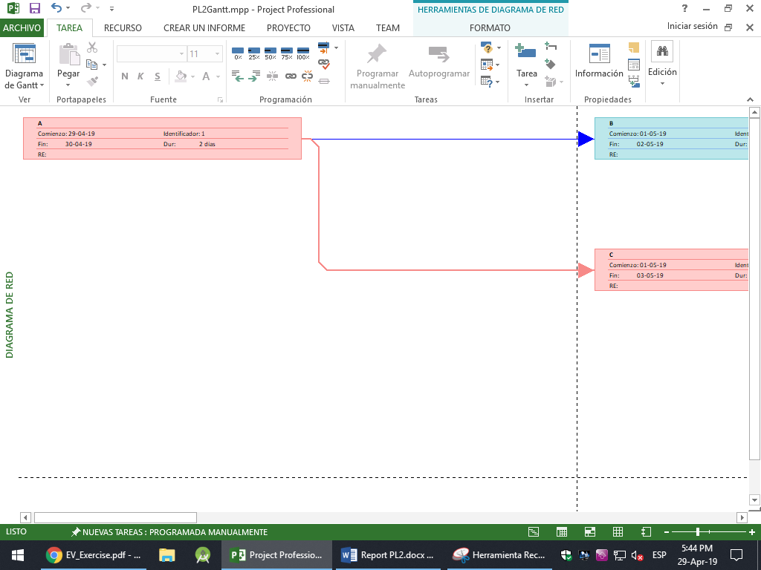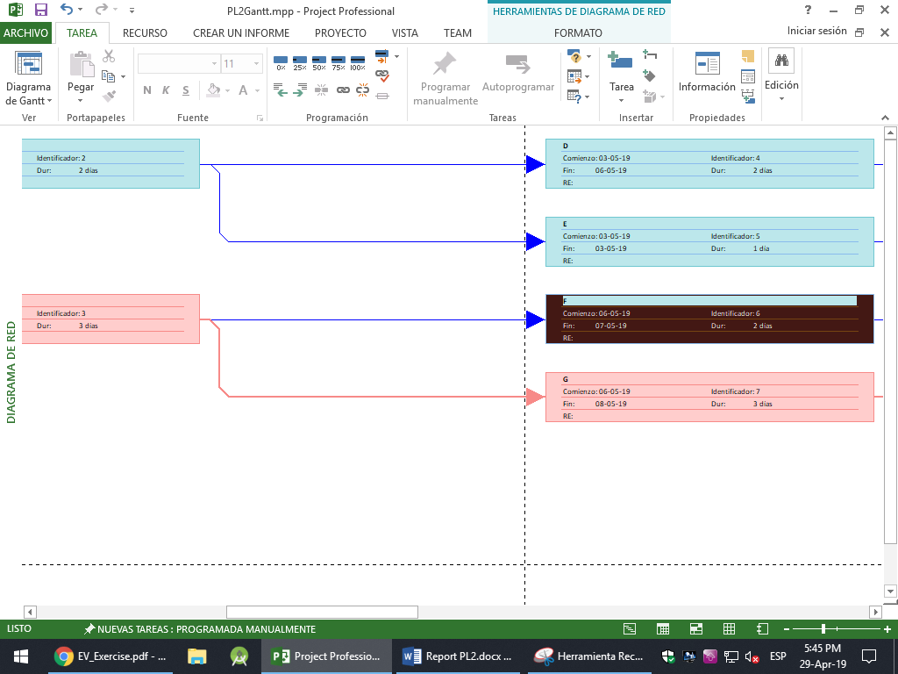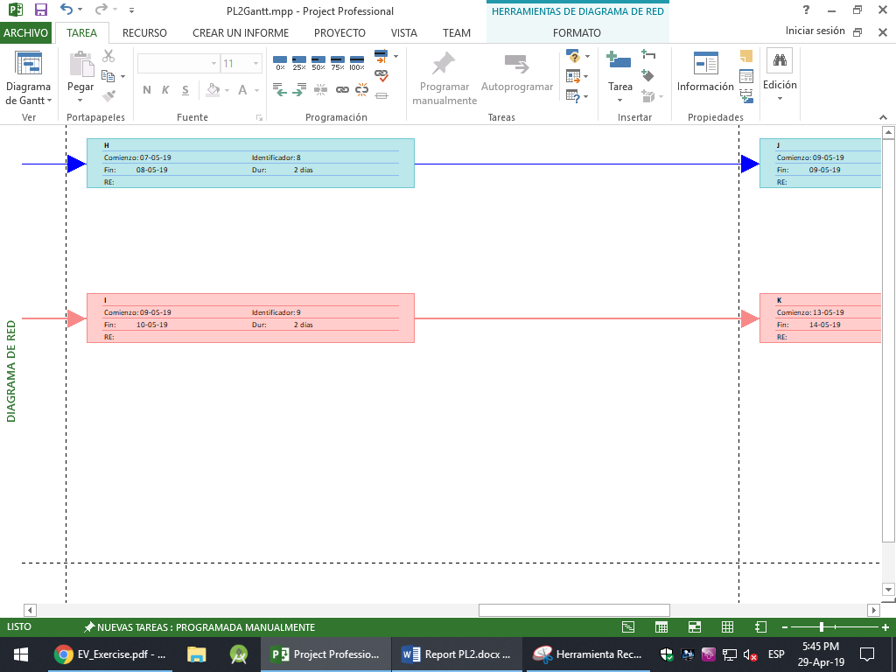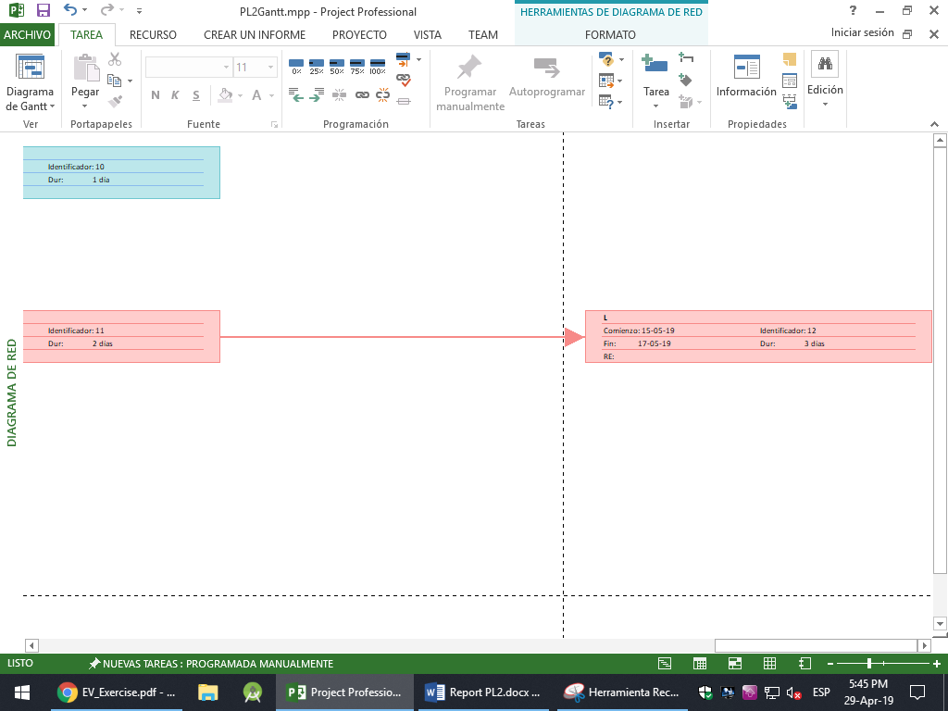

In this diagram, the pink cells represent the critical path, that is, the tasks that will make the project slower, while the blue cells represent tasks that are not in the critical path and do not delay nor slow down the project.

1. Project duration and critical path.

MS Project creates a timeline based on the duration of each task and the beginning date. To view this duration graphically, the option “escala de tiempo” must be selected, and the representation appears next.

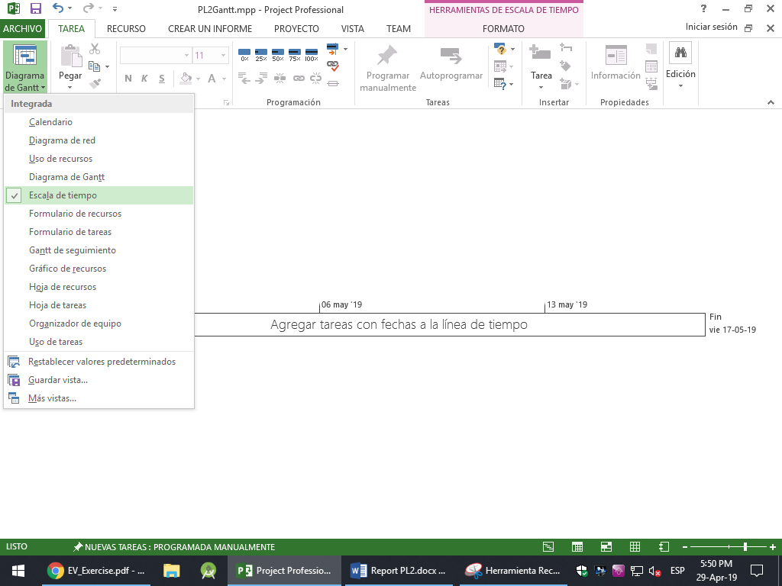

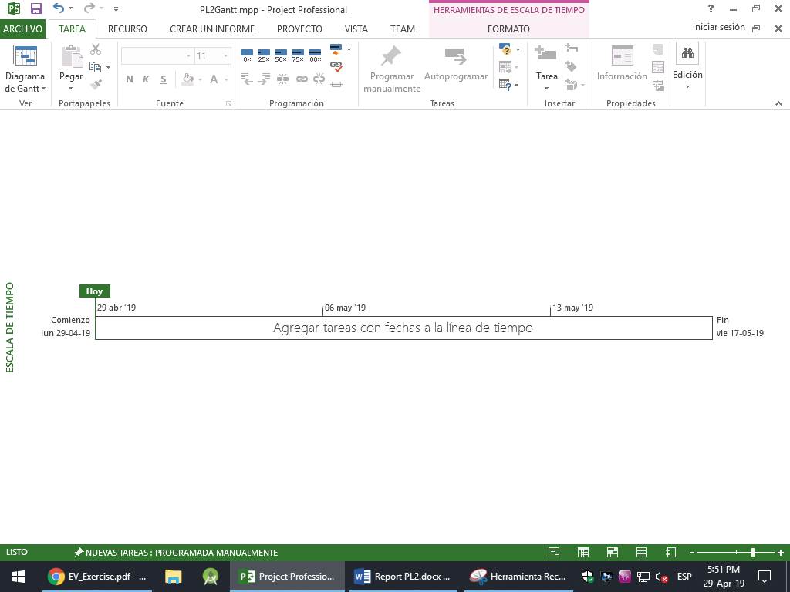

1. Gantt chart.

As previous sections, the Gantt chart is selected in the contextual menu.

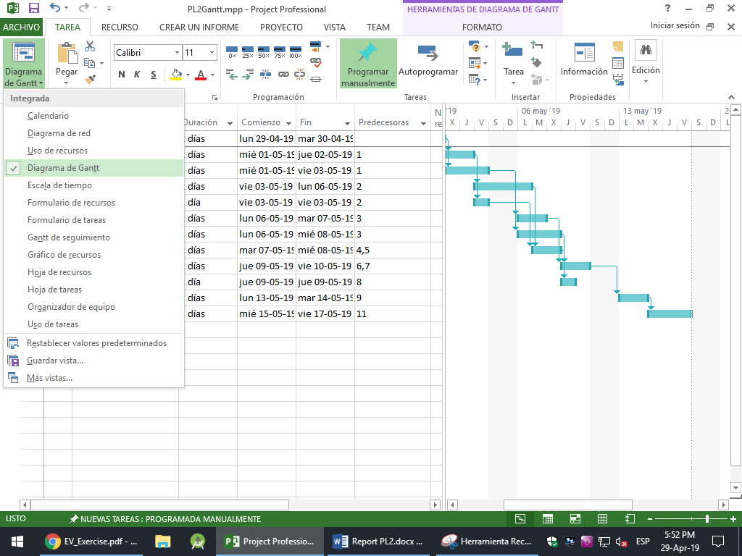

Next, the diagram based on the introduced data is created automatically in the right side of the screen.

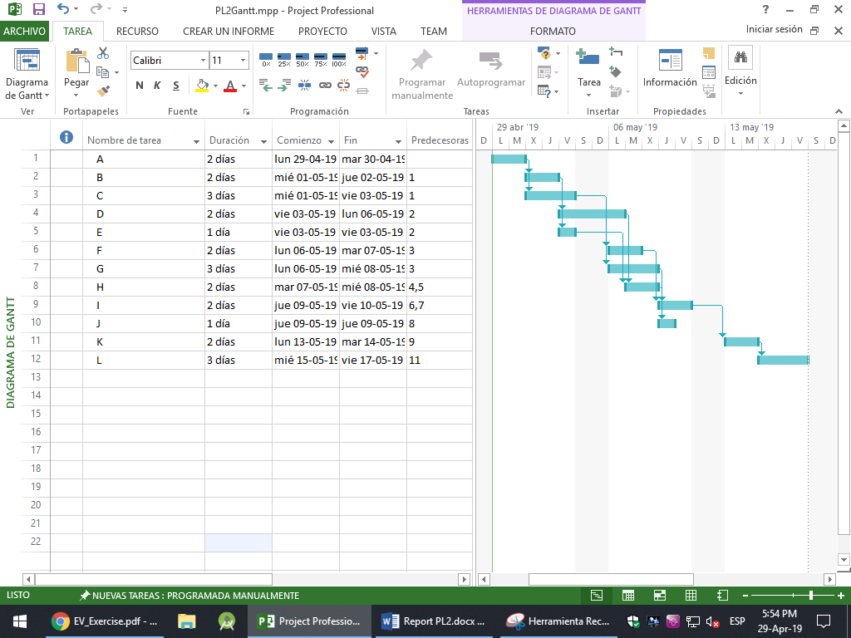

Moreover, MS Project comes with an option to create a following Gantt chart, which tracks the completed percentage of each task, and can be selected this way.

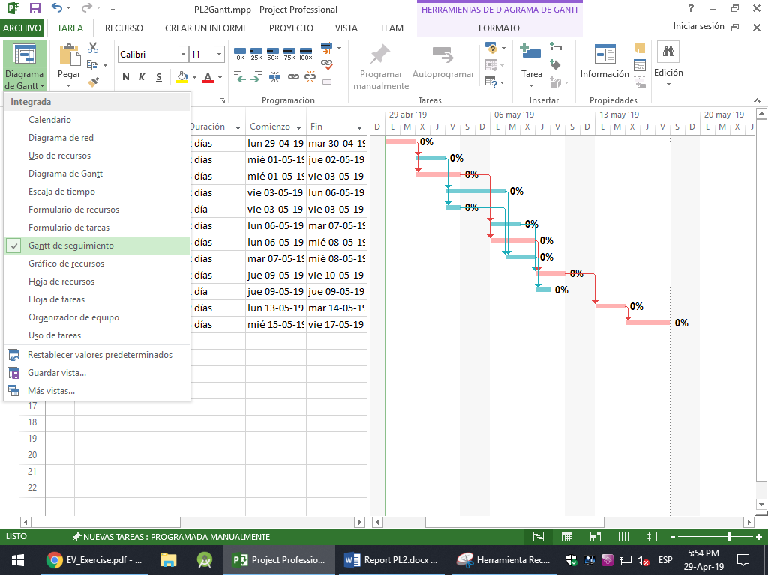

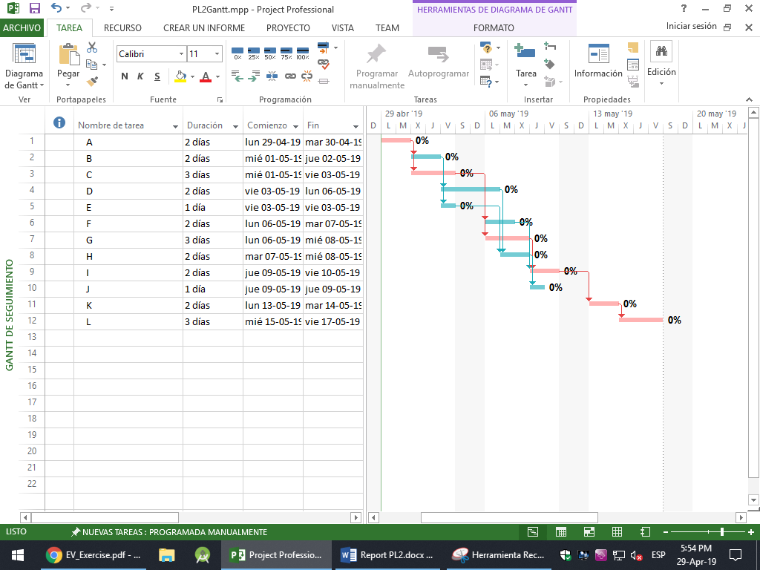

1. Earned Value.

First, the resources and task costs are introduced manually. Then, manually, each task is assigned to each resource following the given data. If the data is introduced as the problem states, each worker will have more hours than allowed, so it is needed to reassign each task and postpone some tasks for later. This is done automatically, and the results are these.

